FODS ASSIGNMENT-3:

JURY OF ALAMEDA COUNTY

Null Hypothesis:

Panels were selected at random from the population of eligible jurors.

Alternate Hypothesis:

Panels were not selected through random sampling.

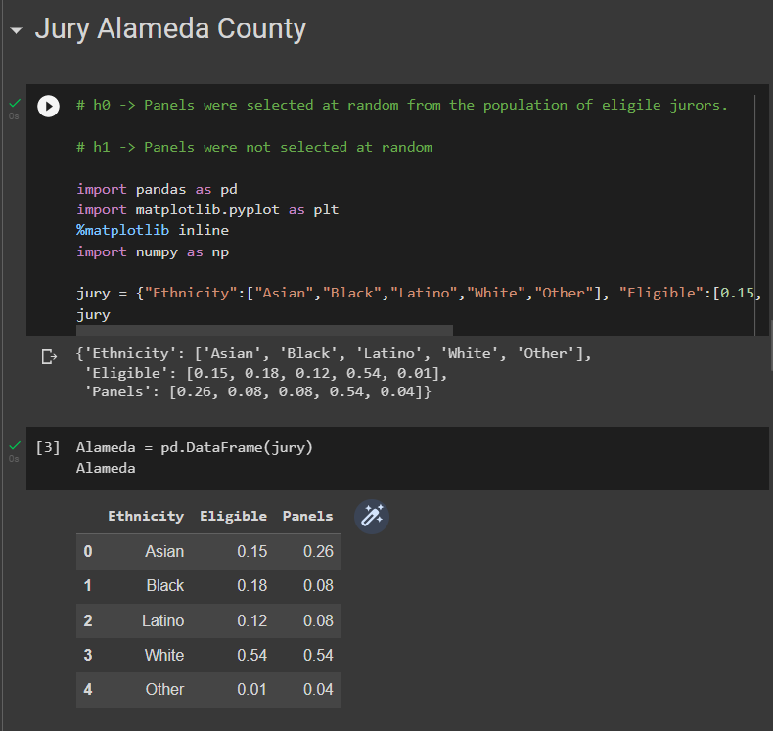

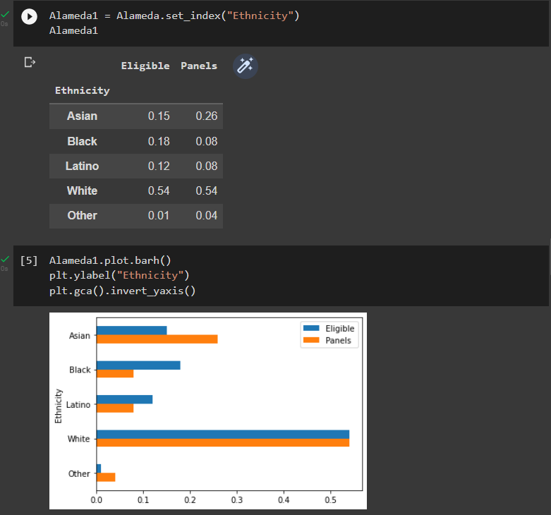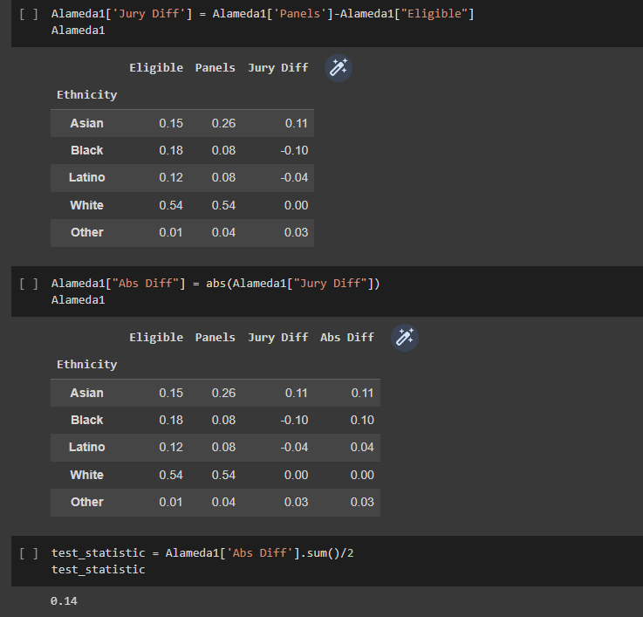

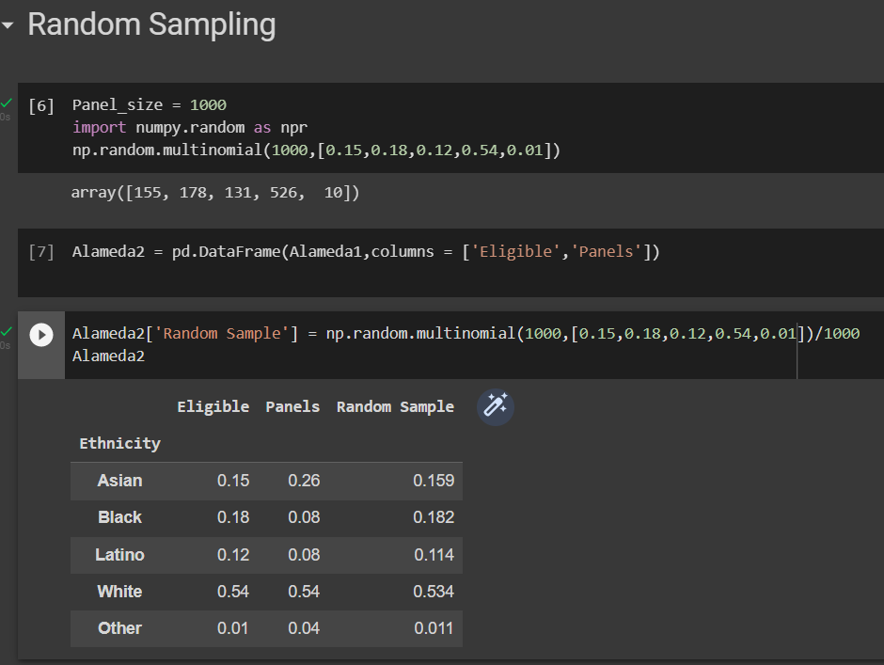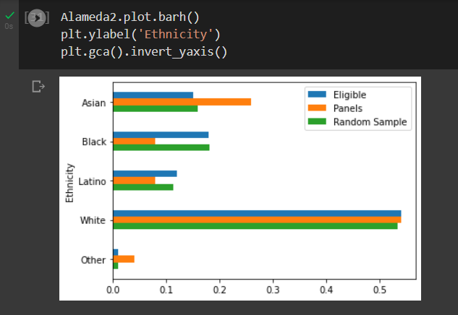

Inference: This bar shows that if the samples are selected randomly then it is closer to the eligible population than it is to the actual panels.

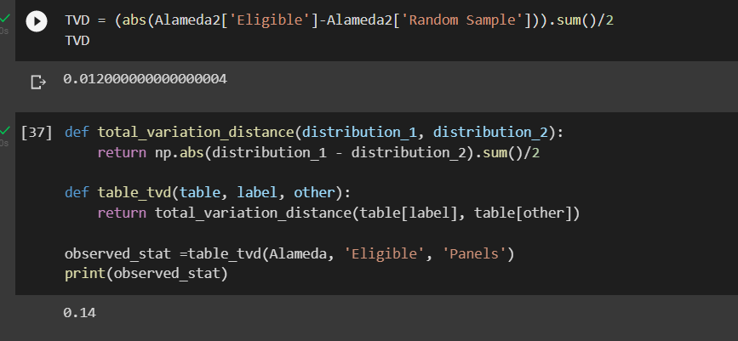

Running a simulation of 5000 times to get detailed evidence for TVD between eligible population and random sample.

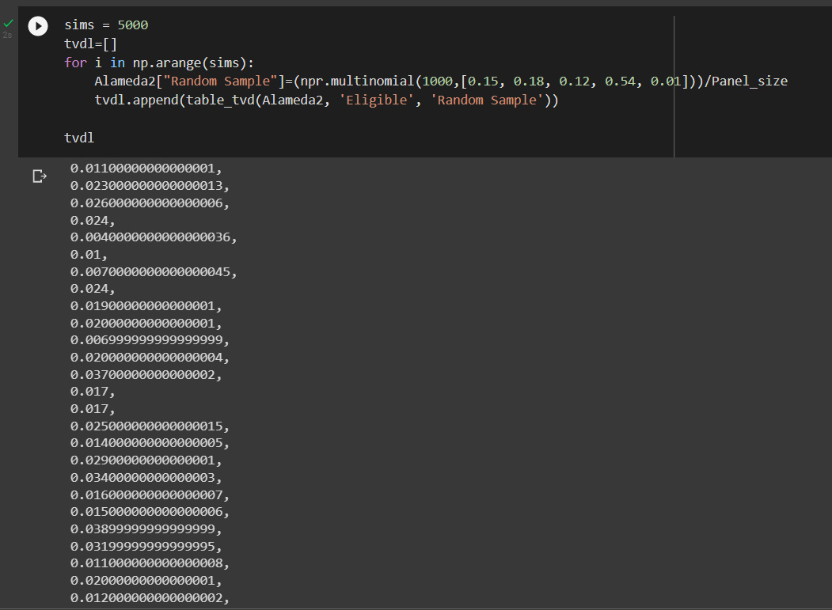

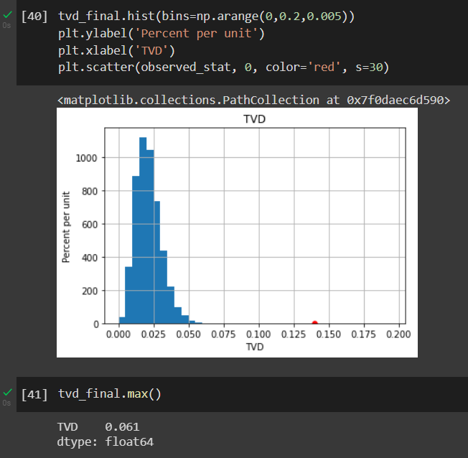

Inference: this graph therefore shows us that the total variation distance between eligible population and the panels is way too high compared to the simulation of 5000 times with a panel size of 1000 where the total variation distance between eligible population and the random sample is atmost only 0.061, so we can conclude that the panels were not randomly sampled.

Hence, the Null hypothesis is rejected